DATA24 INSTALLATION & DATA FETCH TO AMIBROKER
- DATA24 Installation
Step 1: Download Data24 set up file using the following link:
https://mbs.com.vn/vi/khach-hang-ca-nhan/dich-vu-chung-khoan/dich-vu-dien-tu
Choose set up file accordingly for Win32 / Win64.
Step 2: Double click setup.exe to start installation process.
Double click setup.exe
Step 3: Press Next
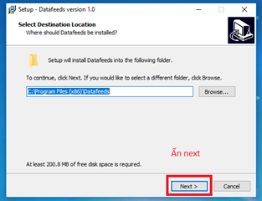
Press Next

Step 4: Tick “Create a desktop shortcut” and press Next

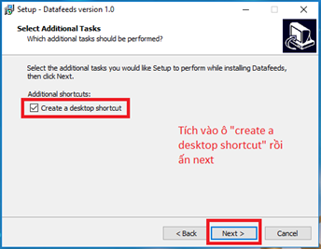
Tick Create

Step 5: Press Install

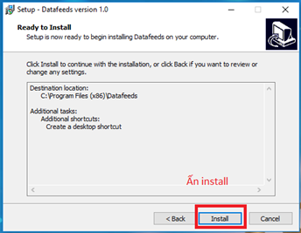
Press Install

Step 6: After the process is done, click Finish

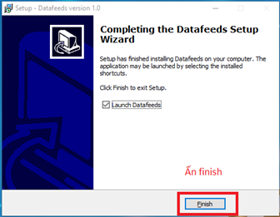
Press Finish

Step 7: Input account name and password to log in.

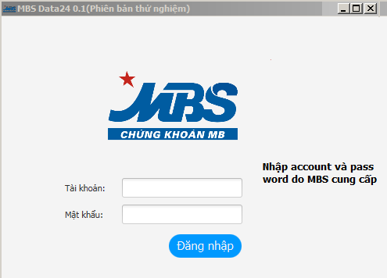
Input account name and password

- DATA FETCH FROM DATA24 TO AMIBROKER

Step 1:
Create a blank folder in drive D or E ( drive C is not recommended). In this guidance, we create folder “Data24” in drive E. Then open Amibroker => File => New => Database.

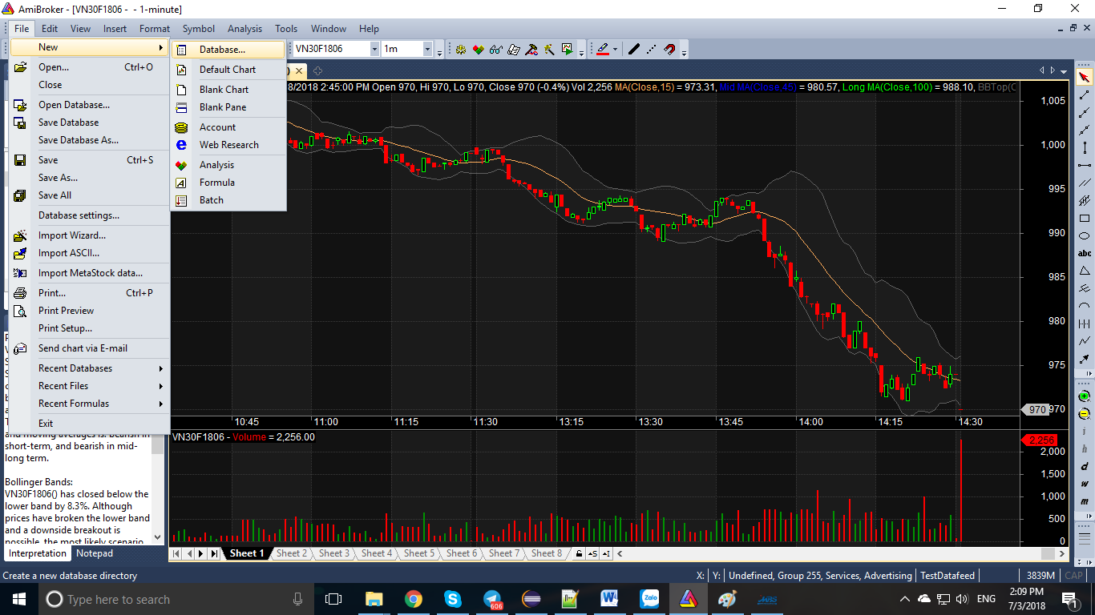

Step 2: Press Browse

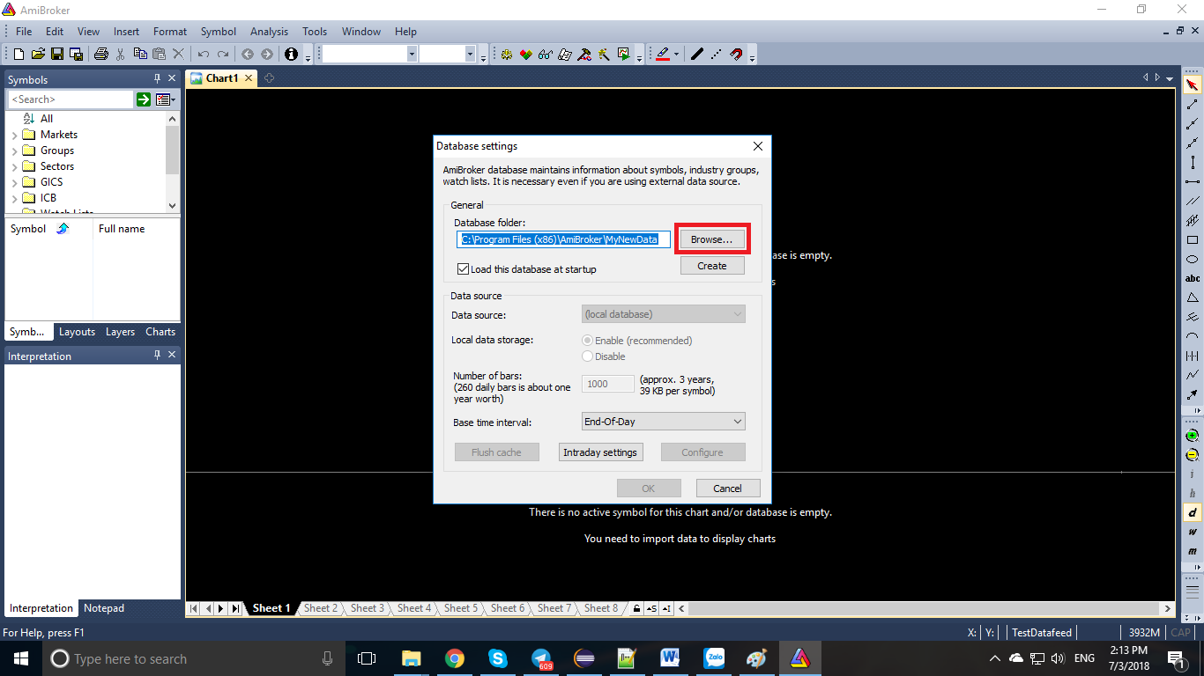

Step 3: Navigate to the blank folder “Data24” and press “Open”
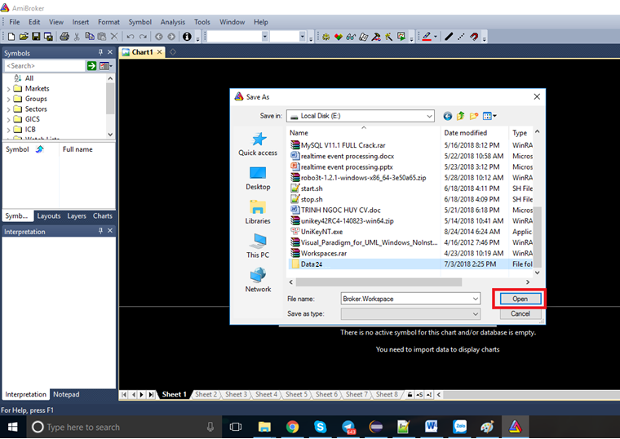

Step 4: Press Save
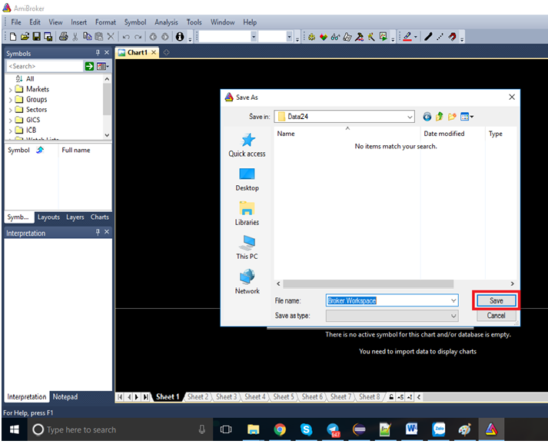

Step 5: Press Create
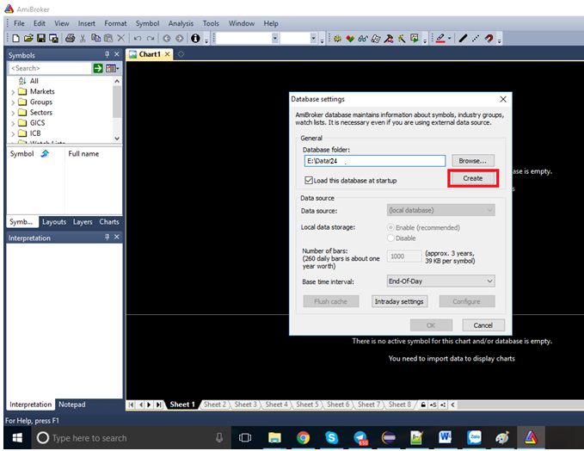

Step 6: Input 10000 as the number of bars and press OK to finish setting AmiBroker.
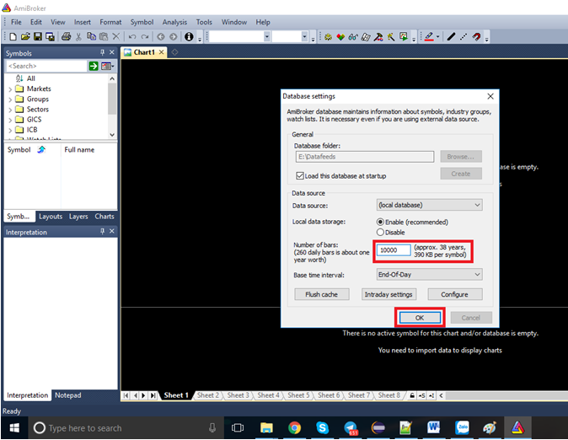

- LOG IN TO DATA24 TO FETCH DATA
After logging in to Data24, please set up as followings to fetch data:
Step 1: Press “Cấu hình”
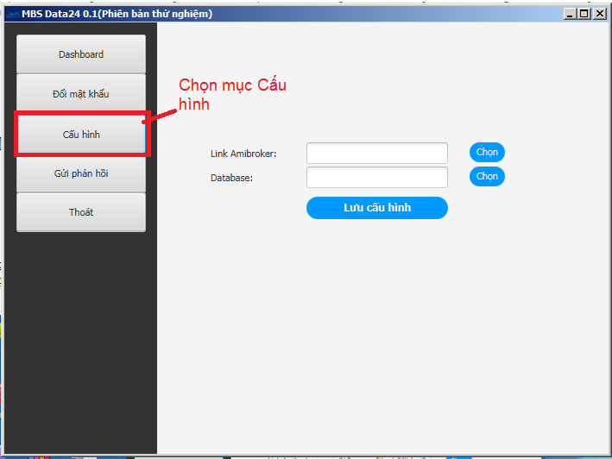
Press Cấu hình

Step 2: Navigate to Amibroker installation folder and data folder (usually this folder is in drive C as followings: C:\Program Files\AmiBroker), then press “Lưu cấu hình”.

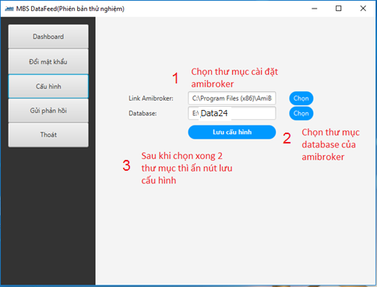
Press “Lưu cấu hình”
Navigate to Amibroker database
Navigate to Amibroker

Step 3: Navigate back to Dashboard to fetch data
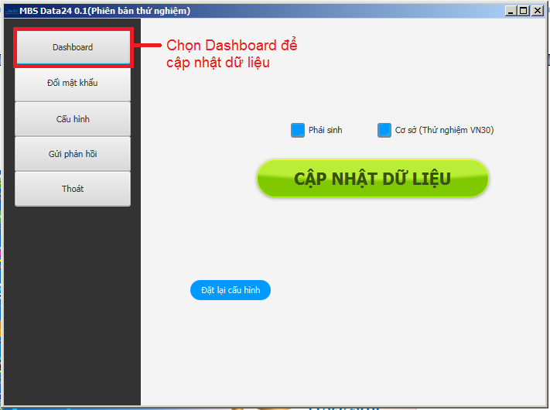
Press “Dashboard”
Step 4: Choose the data to fetch (derivatives or equities or both) and press “Cập nhật dữ liệu”.
Note: Amibroker must be opened beforehand during data fetching. Data will be fetched and displayed right in Amibroker.
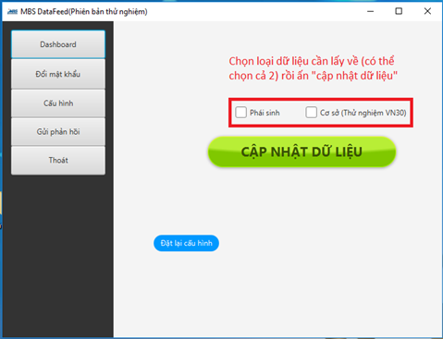
Choose data to fetch (could be both), and press “Cập nhật dữ liệu”

After finishing fetching data, check Amibroker to make sure data is successfully fetched.
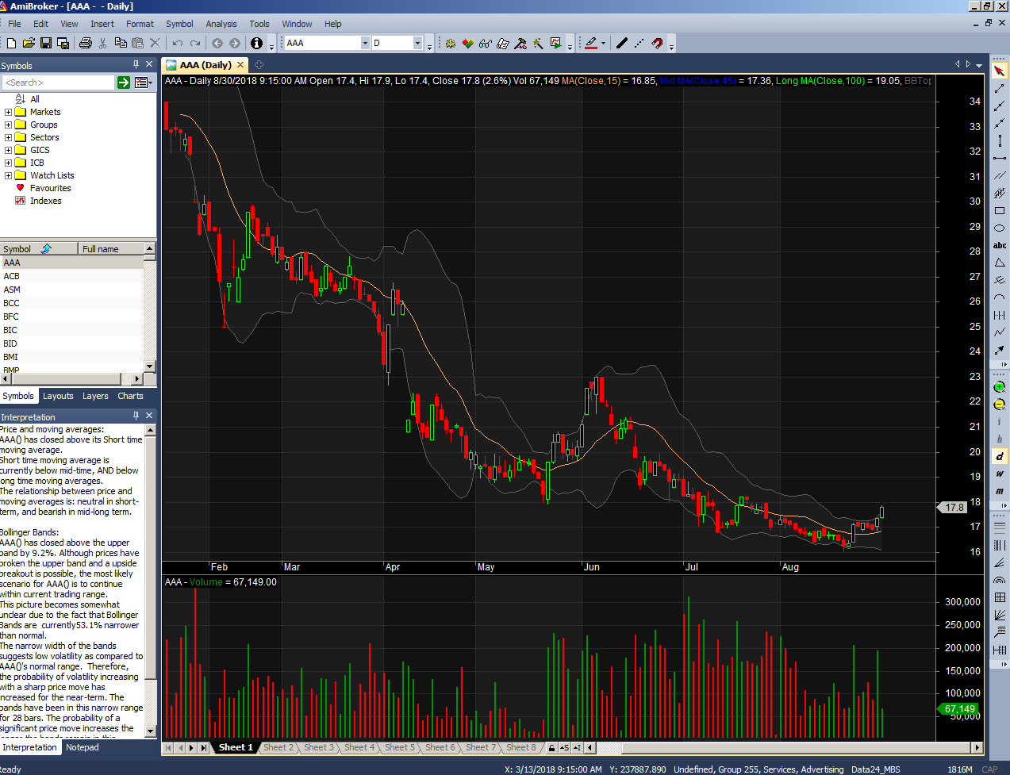

- SOME FUNCTIONS IN DATA24
- Change password:
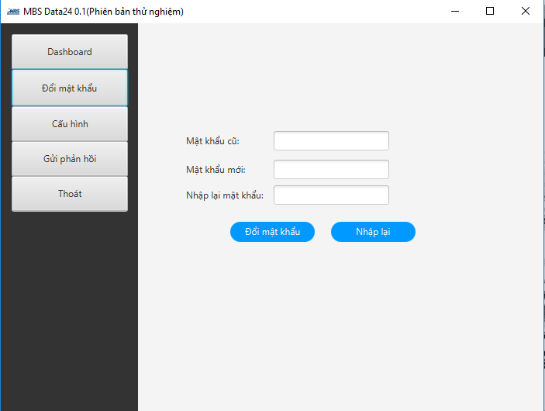
We can change the current password to a new one. As a sidenote, the default password should be changed. The password should contain at least 8 characters and maximum 50 characters.
- Feedback to MBS

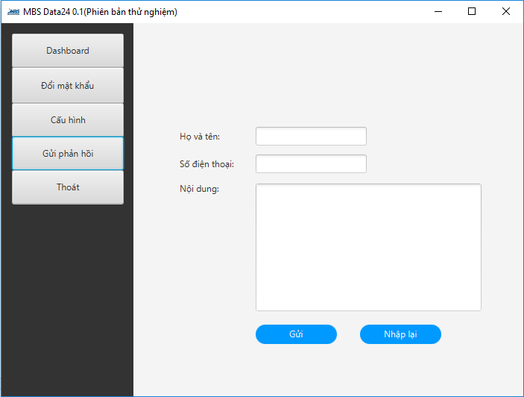

In this screen the errors and/or inconveniences of Data24 could be reported to MBS for app updates.

